These are the 10 products that I have currently listed on Amazon. Below is the name and the Amazon link that I want to link for these products.

Please use the below product names and links consistently across the website.

For Shop on Amazon button CTA on Home page header, use
https://www.amazon.in/stores/LernZeit/page/EE0E082E-9D60-4856-855D-FF6A87C6EB14?ref_=cm_sw_r_ud_sf_stores_MW8KZZBAHJ6TEAV6JZW3

List of 10 products & their URLs:

Storytelling & Sequencing Flashcards
https://link.amazon/B0i9MIngd

Learn To Ask Questions | Flashcards, Level 1
https://link.amazon/B003bHHGq

Learn To Ask Questions | Flashcards, Level 2
https://link.amazon/B0j7SMtQ4

Learn to Ask Questions | Flashcards, Level 1 & 2 Combo
https://link.amazon/B05EX4tCP

Everyday Bharat Objects | Flashcards, Level 1
https://link.amazon/B01pr56rG

Everyday Bharat Objects | Flashcards, Level 2
https://link.amazon/B0hySO4Uh

Everyday Bharat Objects | Flashcards, Levels 1 & 2 Combo
https://link.amazon/B09r1KMC5

Tenses Through Festivals Flashcards, Level 1
https://link.amazon/B05ewcW4G

Tenses Through Festivals Flashcards, Level 2
https://link.amazon/B0htLXRhY

Tenses Through Festivals Flashcards, Levels 1 & 2 Combo
https://link.amazon/B0bK7MV4U

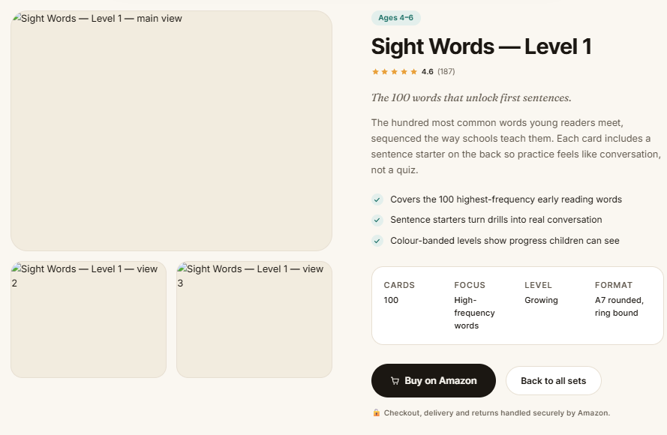
I am pasting the information in the above template for all 10 product listings below.

One Change in Page order:
After the cards / Focus / Level / Format panel and before the “Buy on Amazon" button, I want to add following two things
- Best For
- Themes Included

And then for all listings, below the trust line, I want a shared feature strip that has below content. This could be in a small font size similar to trust line. Also this information is the same for all 10 products. So we can use the below for all products.
6 Ways to Play · Flip and Check · Double-Sided Lamination · Child-Safe Rounded Corners
For the review and count of ratings, can we pull from Amazon page in realtime so that it can dynamically get updated?

Shared Page Elements

Secondary button
Back to All Games
CTA: “Products” page

Amazon trust line
Checkout, delivery and returns are handled securely by Amazon.

Shared feature strip
6 Ways to Play · Flip and Check · Double-Sided Lamination · Child-Safe Rounded Corners

Individual Page Information

1. Storytelling & Sequencing

Age label
Best suited for ages 4–8

Product title
Storytelling & Sequencing

Introductory line
Five-card stories that help children put ideas in order.

Description
Children arrange picture cards into meaningful sequences, narrate what happened and imagine what could happen next. Familiar daily-life and nature themes make storytelling easier to understand, while the flip-and-check format provides helpful guidance.

Key benefits
- Helps children tell stories and organise ideas clearly
- Strengthens logical thinking, sequencing and prediction
- Builds vocabulary, comprehension and empathy through visual stories

Product information
Cards
40
Focus
Tell stories and organise ideas
Level
Mixed ability
Format
Double-sided laminated cards with rounded corners

Best for
Quick 5–10 minute play · Parent–child time · Travel and waiting time · Classroom or small-group use

Themes included
Daily routines, hygiene, creativity, responsibility, food chains and plant and animal life cycles.

Amazon button
Buy on Amazon
URL: https://link.amazon/B0i9MIngd

2. Learn to Ask Questions — Level 1

Age label
Best suited for ages 4–5

Product title
Learn to Ask Questions — Level 1

Introductory line
Real-life situations that turn natural curiosity into meaningful questions.

Description
Children observe familiar scenes, think about what is happening and practise forming clear questions. The self-checking flip-and-check design helps them explore possible answers while building communication and social understanding.

Key benefits
- Helps children ask better and more relevant questions
- Builds curiosity, observation and early critical thinking
- Encourages confident communication, empathy and good manners

Product information
Cards
40
Focus
Ask better questions
Level
Beginner
Format
Double-sided laminated cards with rounded corners

Best for
Quick 5–10 minute play · Parent–child time · Classroom or small-group use

Themes included
Friendship, family, school, feelings, manners, safety, curiosity and everyday life skills.

Amazon button
Buy on Amazon
URL: https://link.amazon/B003bHHGq

3. Learn to Ask Questions — Level 2

Age label
Best suited for ages 6–10

Product title
Learn to Ask Questions — Level 2

Introductory line
Deeper situations for sharper questions and more thoughtful conversations.

Description
More advanced scenarios encourage children to observe closely, consider different perspectives and form meaningful questions. Children respond first and then flip the card for guidance, making each activity engaging and self-checking.

Key benefits
- Develops deeper questioning and critical-thinking skills
- Helps children explain ideas and speak with confidence
- Builds awareness of values, choices and real-world situations

Product information
Cards
40
Focus
Ask better questions and speak with confidence
Level
Growing
Format
Double-sided laminated cards with rounded corners

Best for
Parent–child time · Classroom or small-group use · Quick 5–10 minute play

Themes included
Nature and environment, community helpers, healthy habits, festivals, problem-solving, values and character.

Amazon button
Buy on Amazon
URL: https://link.amazon/B0j7SMtQ4

4. Learn to Ask Questions — Levels 1 & 2 Combo Pack

Age label
Best suited for ages 5–10

Product title
Learn to Ask Questions — Levels 1 & 2 Combo Pack

Introductory line
A complete journey from first questions to confident conversations.

Description
This gift-ready Combo Pack brings together both progressive levels. Children begin with familiar everyday situations and gradually move towards deeper questions involving problem-solving, values and the world around them.

Key benefits
- Offers progressive question-building across two levels
- Strengthens observation, comprehension and communication
- Encourages curiosity, empathy and confident self-expression

Product information
Cards
80
Focus
Ask better questions and speak with confidence
Level
Complete two-level journey
Format
Double-sided laminated cards with rounded corners

Best for
Gifting · Parent–child time · Classroom or small-group use

Themes included
All themes from Levels 1 and 2, including family, school, feelings, safety, nature, community, healthy habits, festivals, problem-solving and values.

Amazon button
Buy the Combo Pack
URL: https://link.amazon/B05EX4tCP

5. Everyday Bharat Objects — Level 1

Age label
Best suited for ages 4–5

Product title
Everyday Bharat Objects — Level 1

Introductory line
Familiar Indian objects that make first vocabulary feel close to home.

Description
Children discover objects they see in Indian homes and everyday life through pictures, stories and conversation. They identify, describe and connect each object to familiar experiences before flipping the card to learn more.

Key benefits
- Builds vocabulary using culturally relevant objects
- Develops identification, description and classification skills
- Connects language learning with everyday Indian life

Product information
Cards
40
Focus
Build vocabulary and everyday awareness
Level
Beginner
Format
Double-sided laminated cards with rounded corners

Best for
Quick 5–10 minute play · Parent–child time · Travel and waiting time

Themes included
Indian household objects, festivals, traditions, values, vocabulary and storytelling.

Amazon button
Buy on Amazon
URL: https://link.amazon/B01pr56rG

6. Everyday Bharat Objects — Level 2

Age label
Best suited for ages 6–10

Product title
Everyday Bharat Objects — Level 2

Introductory line
Culture-rich objects that inspire richer words, stories and connections.

Description
Children move beyond naming objects to exploring their cultural meaning, uses and connections with Indian traditions. Story-led activities help them describe, compare and express ideas using stronger vocabulary.

Key benefits
- Expands culturally relevant vocabulary and general awareness
- Encourages description, comparison and storytelling
- Builds appreciation for Indian traditions, crafts and heritage

Product information
Cards
40
Focus
Build vocabulary and everyday awareness
Level
Growing
Format
Double-sided laminated cards with rounded corners

Best for
Parent–child time · Classroom or small-group use · Quick 5–10 minute play

Themes included
Indian traditions, cultural symbols, crafts, music, festivals, rituals, values, heritage, empathy and storytelling.

Amazon button
Buy on Amazon
URL: https://link.amazon/B0hySO4Uh

7. Everyday Bharat Objects — Levels 1 & 2 Combo Pack

Age label
Best suited for ages 5–10

Product title
Everyday Bharat Objects — Levels 1 & 2 Combo Pack

Introductory line
A gift-ready journey through Indian objects, language and stories.

Description
This two-level collection takes children from recognising familiar Indian objects to discovering the stories, traditions and values connected with them. It offers a richer vocabulary-building journey through culturally meaningful play.

Key benefits
- Builds vocabulary progressively across two levels
- Develops cultural awareness, classification and storytelling
- Encourages meaningful conversations across generations

Product information
Cards
80
Focus
Build vocabulary and everyday awareness
Level
Complete two-level journey
Format
Double-sided laminated cards with rounded corners

Best for
Gifting · Parent–child time · Classroom or small-group use

Themes included
All themes from Levels 1 and 2, including Indian homes, festivals, traditions, crafts, music, rituals, cultural symbols and values.

Amazon button
Buy the Combo Pack
URL: https://link.amazon/B09r1KMC5

8. Tenses Through Festivals — Level 1

Age label
Best suited for ages 4–6

Product title
Tenses Through Festivals — Level 1

Introductory line
A playful first step into past, present and future tenses.

Description
Children learn how actions change across time through familiar Indian festival scenes. They observe the picture, build or complete a sentence and flip the card to check the tense and language guidance.

Key benefits
- Introduces past, present and future tenses in context
- Builds sentence formation, vocabulary and speaking confidence
- Connects early grammar learning with familiar Indian festivals

Product information
Cards
45
Focus
Understand English tenses
Level
Beginner
Format
Double-sided laminated cards with rounded corners

Best for
Homework and revision · Parent–child time · Classroom or small-group use

Themes included
Past, present and future tenses, Indian festivals, action words, sentence formation, vocabulary and cultural awareness.

Amazon button
Buy on Amazon
URL: https://link.amazon/B05ewcW4G

9. Tenses Through Festivals — Level 2

Age label
Best suited for ages 7–10

Product title
Tenses Through Festivals — Level 2

Introductory line
More challenging verbs and festival contexts for growing grammar skills.

Description
Children practise using past, present and future forms with more complex actions, irregular verbs and multi-step festival situations. The flip-and-check format provides immediate language guidance after every attempt.

Key benefits
- Strengthens tense usage through meaningful sentence practice
- Introduces more complex and irregular verb forms
- Builds grammar confidence through culturally familiar situations

Product information
Cards
45
Focus
Understand English tenses
Level
Growing
Format
Double-sided laminated cards with rounded corners

Best for
Homework and revision · Classroom or small-group use · Parent–child time

Themes included
Past, present and future tenses, Indian festivals, irregular and multi-step verbs, rituals, traditions and expressions of devotion.

Amazon button
Buy on Amazon
URL: https://link.amazon/B0htLXRhY

10. Tenses Through Festivals — Levels 1 & 2 Combo Pack

Age label
Best suited for ages 5–10

Product title
Tenses Through Festivals — Levels 1 & 2 Combo Pack

Introductory line
A complete, gift-ready journey through English tenses and Indian festivals.

Description
The Combo Pack brings together both progressive levels, helping children move from recognising basic tense changes to using more complex verbs and sentence structures. Familiar festival contexts keep grammar meaningful and memorable.

Key benefits
- Covers past, present and future tenses across two levels
- Supports progressive sentence building and grammar practice
- Combines English learning with Indian cultural awareness

Product information
Cards
90
Focus
Understand English tenses
Level
Complete two-level journey
Format
Double-sided laminated cards with rounded corners

Best for
Gifting · Homework and revision · Classroom or small-group use

Themes included
All themes from Levels 1 and 2, including Indian festivals, action words, sentence formation, irregular verbs, rituals and traditions.

Amazon button
Buy the Combo Pack
URL: https://link.amazon/B0bK7MV4U

